
Cognizant Technology
Solutions India Private Ltd.
Techno Campus
5/535 Old Mahabalipuram Road
Okkiyam Thoraipakkam
Chennai 600 097
India
Phone 4209 6000
Fax +4209 606
www.cognizant.com
[Please change the company name and address depending on Cognizant company/ entity and country location that employed the associate]

[Note: please remove brackets/ parenthesis as well as the language in brackets as they are notes to you as you complete this letter. Manager must provide true and accurate details in this statement - attestation]

([Month Day, Year ex. March 2, 2017])

U.S. Department of Homeland Security
U.S. Citizenship and Immigration Services

Re: Associate’s name as in passport [First Name Last Name]

To Whom It May Concern:

This letter is issued in reference to [Mr./Ms.] [Associate First Name Last Name]’s and [his/her] job duties. I have firsthand knowledge of [Mr./Ms.] [Associate Last Name]’s full-time, 40 hours per week employment in a managerial role at Cognizant [ENTER COMPANY/AFFILIATE NAME] in [Country] from [Month day, year] to [Month Day, Year] -[Note: please provide date that you personally served as associate’s manager while the associate was in a managerial role offshore]. I hold the position of [Band/ Grade] at Cognizant in [Country] and served as [Mr./Ms.] [Associate Last Name]’s manager in [Country] during the mentioned time period. [IF YOU WERE NOT HIS/ HER DIRECT MANAGER, PLEASE MAKE CORRECTION]

[Note: please remove or modify content below if the associate did not perform the stated duties or exercise the stated level of managerial responsibility – please also delete this comment from the final letter]
[Mr./Ms.] [Associate Last Name] provided advice and guidance to on-shore and off-shore professional Cognizant team members with respect to customized software design and development to ensure compliance with technical specifications, and to ensure foremost customer satisfaction. Importantly, in today’s fast-paced, highly globalized information technology environment, Cognizant necessarily employs both local “on the ground” teams and offshore teams to conduct essential functions including the development of customized information technology tools. As such, [Mr./Ms.] [Associate Last Name] served as a manager who exhibited proficiency in planning the day-to-day activities of [his/ her] offshore team that was performing an indispensable function, while at the same time coordinating with teams performing duties related to the same project on-site. [Mr./Ms.] [Associate Last Name] built team spirit by presiding over team meetings to establish project goals and objectives while ensuring full understanding and compliance with project plans. [He/ She] used [his/ her] vast IT project management experience to direct day-to-day activities of onsite and offshore professional team members who were assigned the work based on the particular phase or component of the project(s), as well as provided guidance based on [his/ her] in-depth experience with the principles, techniques, and technologies necessary to complete the project(s). [Mr./Ms.] [Associate Last Name] used [his/ her] established technical skills and an excellent understanding of the underlying technology involved to manage and guide [his/ her] team to achieve quality software deliverable. In short, [Mr./Ms.] [Associate Last Name] provided leadership through project management, including management duties of reporting metrics, such as deliverables to Cognizant senior management. [He/ She] guided the professionals comprising the development team, which required onsite and offshore project management, planning and executing customized systems deliverables, and knowledge transfer (e.g., training professional subordinates). [He/ She] served as an escalation to resolve technical issues, and setting goals and providing performance feedback for subordinates.

[Mr./Ms.] [Associate Last Name]’s day-to-day responsibilities included defining assigned team structure, discretionary authority to hire and fire professional college/university degree holding team members of Cognizant, interviewing potential talent, recommending team members for promotions or salary revisions, and guiding team leads to ensure quality control with respect to technical specifications and processes.

[Mr./Ms.] [Associate Last Name] was responsible for overseeing and managing the implementation of Cognizant’s customized solutions. [Please articulate/discuss with a high level of detail the specific managerial decisions the Associate made for the project(s) offshore without repeating what is mentioned above. As an example – not to be copied and pasted, the following is the type of detail we are seeking: A key managerial duty performed by Mr. Smith was to assess and implement project plan changes related to the utilization of resources by comparing the total effort to the budget effort which had a direct impact on the bottom line of financial revenue, profit and loss for the project(s) wherein underperformance by his Cognizant team members, delays in timeline and unavoidable circumstances all impacted productivity metrics. Additionally, Mr. Smith was charged with managing change requests impacting the established scope of work, which ultimately could derail the entire project if not properly managed in a timely manner and within budgetary guidelines. As well, Mr. Smith held managerial responsibility over quality assurance, which is metrics focused to prevent the entire project from straying from the stated goals and objectives and failing. He had ownership of cost management for his assigned segment of the engagement which was critical to the project’s success and involved a whole host of variables, such as quality, scope and productivity. Mr. Smith reviewed dashboards to show where documentation was lacking and implemented project improvements to prevent delays.]

I provide the below table describing [Mr./Ms.] [Associate Last Name] role and percentage of time: [PLEASE COPY AND PASTE THE TABLE BELOW AS WELL AS THE ORG CHARTS AND DIRECT/ IN-DIRECT SUBORDINATE CHARTS AND COMPLETE THEM FOR EACH PROJECT, AS NEEDED AND INDICATE START AND END DATE IF THERE WAS MORE THAN 1 PROJECT]

(DELETE THE PARENTHESIS AND THESE INSTRUCTIONS AS WELL AS THE SAMPLE TASKS – THIS IS THE TYPE OF DETAIL WE NEED WHICH IS THE PURPOSE OF PROVIDING THE SAMPLE TASKS, AND ENTER the Associate’s Band Title and full name of the Associate as in his/ her passport | Percentage of Time
Identified risks/ challenges and formulate, implement and oversee strategies for process standardization
Established goal setting and direct implementation and oversee learning plans aligned with project needs

Overall test delivery and testing team management for assigned segment of engagement

Authorized and/ or approved test project plans, test strategy and test estimates
Assessed and reviewed metrics and plans against actuals throughout the engagement to ensure compliance with contract terms

Participated in strategic program level meetings and design walkthrough meeting to ensure goals and objectives of the scope of services is met

Oversaw billing, forecasting and time management for assignment segment of engagement

Oversaw and managed day-to-day workflow of professional subordinates.

The below chart depicts [Mr./Ms.] [Associate Last Name]’s role within the hierarchy of the assigned managerial engagement: [MANAGER: Please create and insert org chart for offshore assignment, same non-editable format as shown below (an editable version will be available as the icon showing the parent-child hierarchy from the Client Details tab. It needs to be inserted in full format within margins within the body of this letter). Please start this org chart with your manager, and you followed by the associate/candidate filing the associate, and thereafter his/her reportees (both direct and indirect). Contractors and Diploma holders are not eligible]:

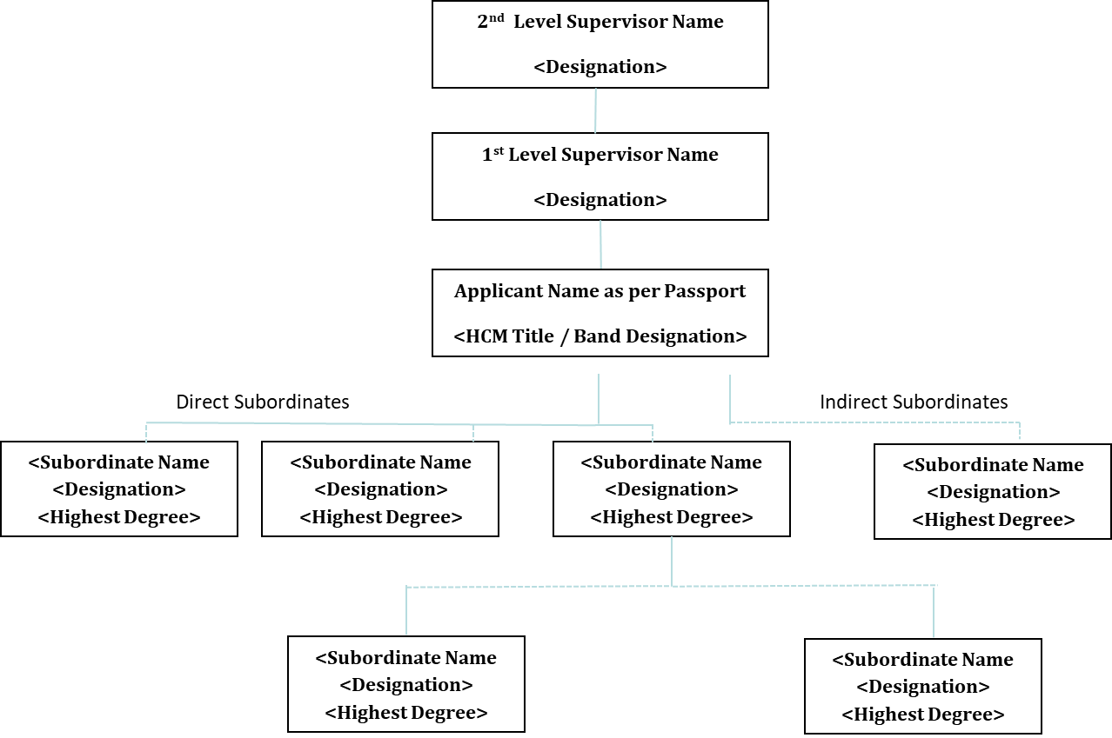

We provide a detailed description of each direct and in-direct subordinate). All of the below team members of Cognizant are professional employees, holding at minimum either a U.S. bachelor’s degree or foreign equivalent. (DELETE THE PARENTHESIS AND THESE INSTRUCTIONS – THIS IS THE TYPE OF DETAIL WE NEED WHICH IS THE PURPOSE OF PROVIDING THE SAMPLE TASKS, PLEASE DO NOT COPY OR OTHERWISE USE THIS SAMPLE TEXT)

Direct Full-Time, 40h per week, Subordinates Names | Job Title & Location | Detailed Job duties and Percentage of Time | Highest Degree
Mr. XYZ | Associate, Offshore | - Developing systems architecture using Java Script, C#, and Cognizant ADPART to conduct quality assurance. This involves coding and scripting applications in a digital platform, 35% of time.  - Implement software enhancements using Cognizant’s C2 framework. This involves reviewing existing programming configurations to updated versions to ensure compatibility of the applications using .Net, 35% of time.  - Compare business requirements to technical specifications to ensure compliance with software design. This involves gather data from business users, assessing user needs, and conducting user acceptance testing to ensure compliance with requirements, 30% of time.

In-Direct Full-Time, 40h per week, Subordinates Names | Job Title & Location | Detailed Job duties and Percentage of Time | Highest Degree
Mr. XYZ | Associate, Offshore | - Developing systems architecture using Java Script, C#, and Cognizant ADPART to conduct quality assurance. This involves coding and scripting applications in a digital platform, 35% of time.  - Implement software enhancements using Cognizant’s C2 framework. This involves reviewing existing programming configurations to updated versions to ensure compatibility of the applications using .Net, 35% of time.  - Compare business requirements to technical specifications to ensure compliance with software design. This involves gather data from business users, assessing user needs, and conducting user acceptance testing to ensure compliance with requirements, 30% of time.

[Mr./ Ms.] [Associate Last Name]’s role and managerial responsibilities did not vary in terms of managing direct and indirect subordinates because Cognizant’s business model includes both a vertical business segment (e.g., industry segment specific, such as banking and finance, healthcare, etc.) and horizontal business segment (e.g., product and service expertise, such as testing and system architecture as well as consulting, among others). Meaning, [Mr./ Ms.] [Associate Last Name] directed, oversaw, assigned work, evaluated the work product, and guided all direct and in-direct subordinates in terms of career development. As to indirect subordinates, there was only one differential which is a corporate system functionality related to performance evaluations. The direct manager submitted the annual performance evaluation for [Mr./ Ms.] [Associate Last Name] indirect subordinates which contained meaningful input from [Mr./ Ms.] [Associate Last Name] for [his/ her] indirect subordinates.

In sum, I attest that [Mr./Ms. Associate Last Name]’s role as [Band Equivalent Title] was managerial, and crucial to ensuring the continued success and leadership of our company.

Sincerely,

(Signature)
[Cognizant Offshore Manager’s Name and Designation]

